**Exercise 7: Packages**

**Scenario 1:** Group all customer-related procedures and functions into a package.

* + **Question:** Create a package **CustomerManagement** with procedures for adding a new customer, updating customer details, and a function to get customer balance.

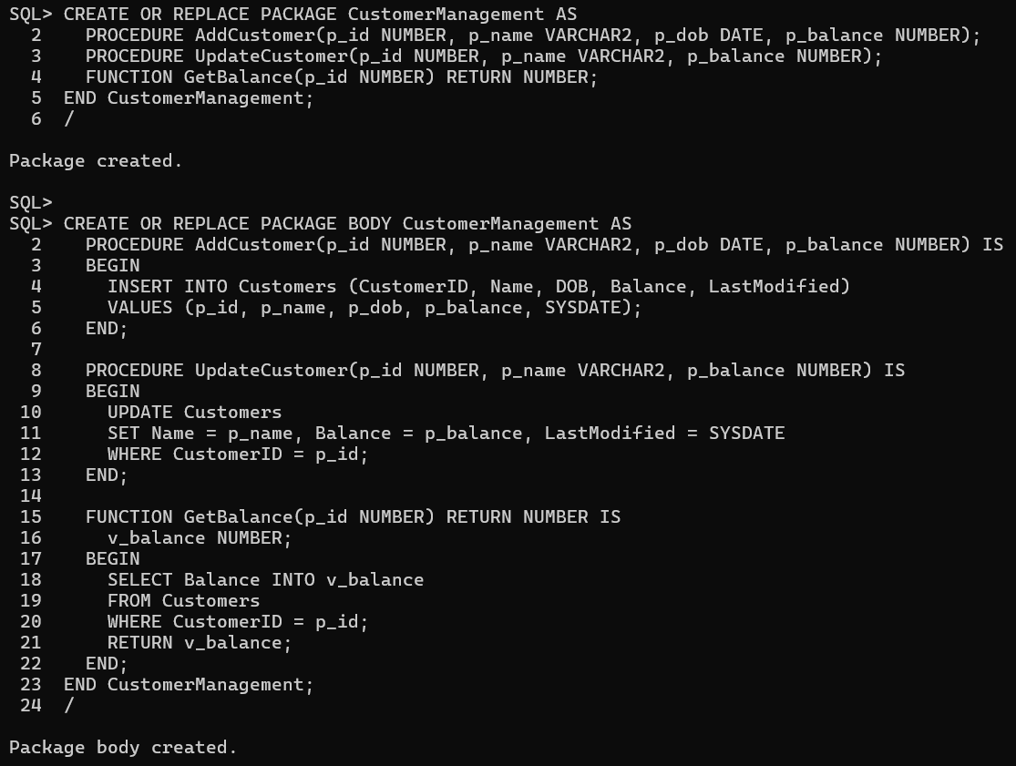

**Scenario 2:** Create a package to manage employee data.

* + **Question:** Write a package **EmployeeManagement** with procedures to hire new employees, update employee details, and a function to calculate annual salary.

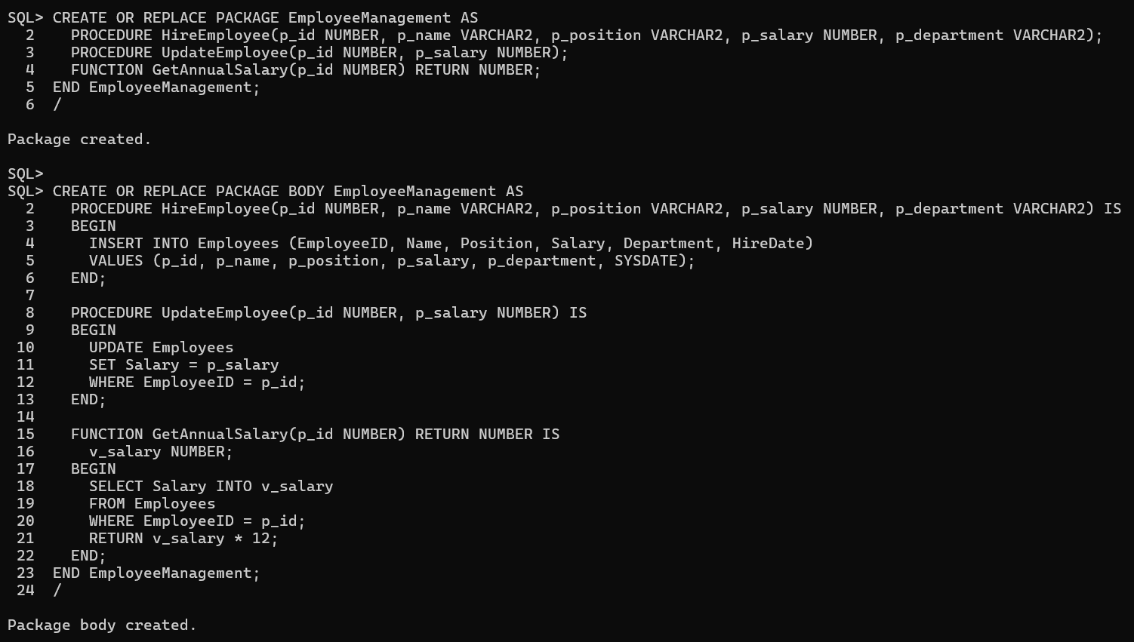

**Scenario 3:** Group all account-related operations into a package.

* + **Question:** Create a package **AccountOperations** with procedures for opening a new account, closing an account, and a function to get the total balance of a customer across all accounts.

